

Carpooling timeline

Software Engineering Project



April 3, 2013

Lahore university of Management sciences

DHA, Lahore Cantonment, Lahore, Pakistan.

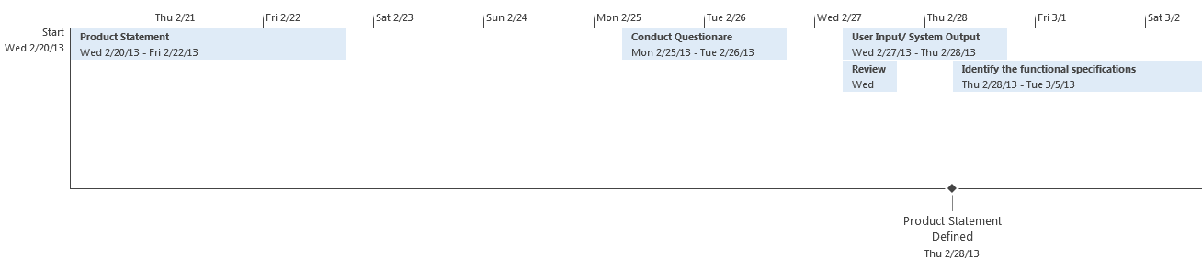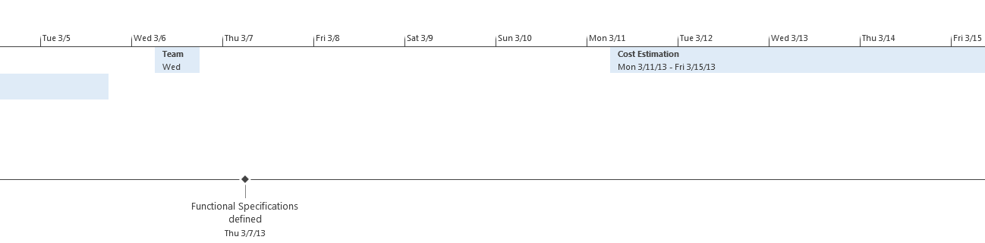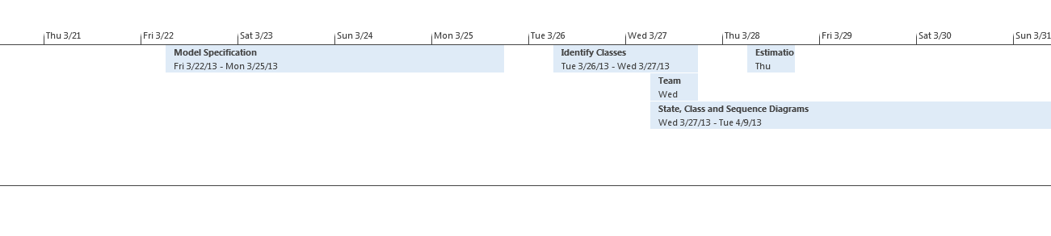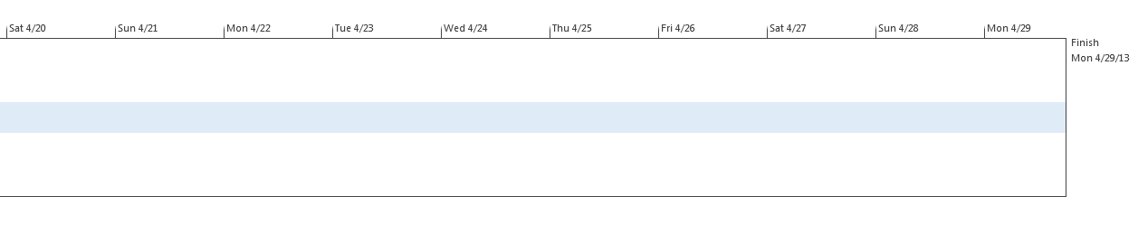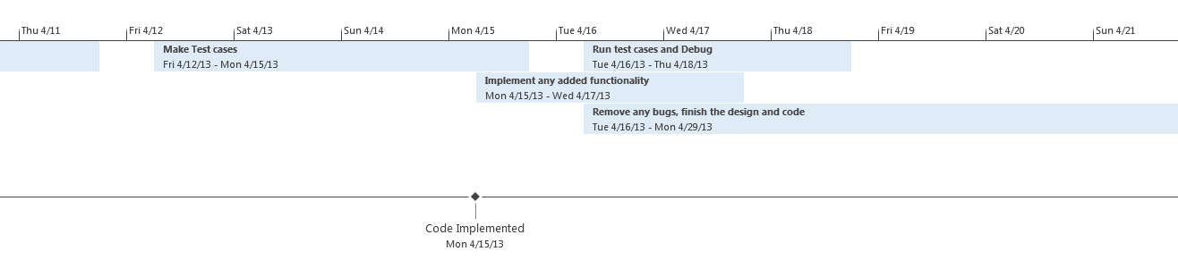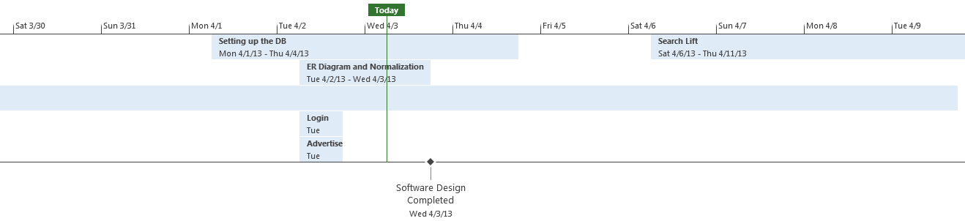

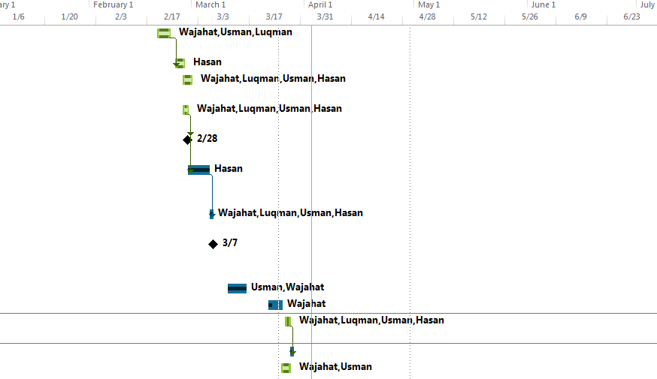Gantt Chart

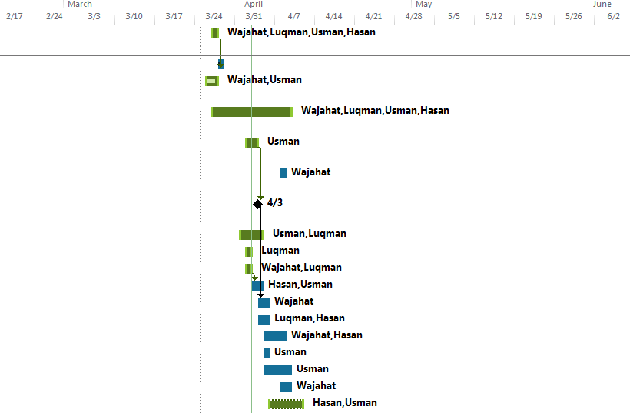

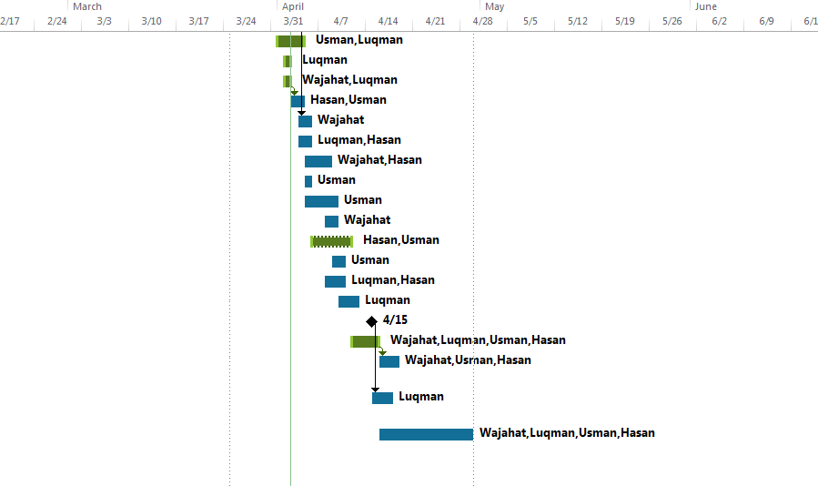

|  |  |  |  |  |  |
| --- | --- | --- | --- | --- | --- |
| Task Name | Duration | Start | Finish | Predecessors | Resource Names |
| Product Statement | 3 days | Wed 2/20/13 | Fri 2/22/13 |  | Wajahat,Usman,Luqman |
| Conduct Questionare | 2 days | Mon 2/25/13 | Tue 2/26/13 | 1 | Hasan |
| User Input/ System Output identification | 2 days | Wed 2/27/13 | Thu 2/28/13 |  | Wajahat,Luqman,Usman,Hasan |
| Review with Course Staff | 1 day | Wed 2/27/13 | Wed 2/27/13 |  | Wajahat,Luqman,Usman,Hasan |
| Product Statement Defined | 0 days | Thu 2/28/13 | Thu 2/28/13 | 4 |  |
| Identify the functional specifications | 4 days | Thu 2/28/13 | Tue 3/5/13 | 4 | Hasan |
| Team meeting with Course Staff | 1 day | Wed 3/6/13 | Wed 3/6/13 | 6 | Wajahat,Luqman,Usman,Hasan |
| Functional Specifications defined | 0 days | Thu 3/7/13 | Thu 3/7/13 |  |  |
| Cost Estimation | 5 days | Mon 3/11/13 | Fri 3/15/13 |  | Usman,Wajahat |
| Model Specification | 2 days | Fri 3/22/13 | Mon 3/25/13 |  | Wajahat |
| Team meeting with Course Staff | 1 day | Wed 3/27/13 | Wed 3/27/13 |  | Wajahat,Luqman,Usman,Hasan |
| Estimation Done | 1 day | Thu 3/28/13 | Thu 3/28/13 | 11 |  |
| Identify Classes | 2 days | Tue 3/26/13 | Wed 3/27/13 |  | Wajahat,Usman |
| State, Class and Sequence Diagrams | 10 days | Wed 3/27/13 | Tue 4/9/13 |  | Wajahat,Luqman,Usman,Hasan |
| ER Diagram and Normalization | 2 days | Tue 4/2/13 | Wed 4/3/13 |  | Usman |
| Pick or design a webpage template | 1 day | Mon 4/8/13 | Mon 4/8/13 |  | Wajahat |
| Software Design Completed | 0 days | Wed 4/3/13 | Wed 4/3/13 | 15 |  |
| Setting up the DB | 4 days | Mon 4/1/13 | Thu 4/4/13 |  | Usman,Luqman |
| Login form | 1 day | Tue 4/2/13 | Tue 4/2/13 |  | Luqman |
| Advertise Lift | 1 day | Tue 4/2/13 | Tue 4/2/13 |  | Wajahat,Luqman |
| Recurring Trip form | 2 days | Wed 4/3/13 | Thu 4/4/13 | 20 | Hasan,Usman |
| User Profile form | 2 days | Thu 4/4/13 | Fri 4/5/13 | 17 | Wajahat |
| Apply For lift | 2 days | Thu 4/4/13 | Fri 4/5/13 |  | Luqman,Hasan |
| Cancel Lift | 2 days | Fri 4/5/13 | Mon 4/8/13 |  | Wajahat,Hasan |
| Check Rating | 1 day | Fri 4/5/13 | Fri 4/5/13 |  | Usman |
| Check My Lifts | 3 days | Fri 4/5/13 | Tue 4/9/13 |  | Usman |
| Update Personal Info | 2 days | Mon 4/8/13 | Tue 4/9/13 |  | Wajahat |
| Search Lift | 5 days | Sat 4/6/13 | Thu 4/11/13 |  | Hasan,Usman |
| Rate your Partner | 2 days | Tue 4/9/13 | Wed 4/10/13 |  | Usman |
| Modify Trip Specs | 3 days | Mon 4/8/13 | Wed 4/10/13 |  | Luqman,Hasan |
| Confirm Lift | 3 days | Wed 4/10/13 | Fri 4/12/13 |  | Luqman |
| Code Implemented | 0 days | Mon 4/15/13 | Mon 4/15/13 |  | Wajahat,Luqman,Usman,Hasan |
| Make Test cases | 2 days | Fri 4/12/13 | Mon 4/15/13 |  | Wajahat,Luqman,Usman,Hasan |
| Run test cases and Debug | 3 days | Tue 4/16/13 | Thu 4/18/13 | 33 | Wajahat,Usman,Hasan |
| Implement any added functionality | 3 days | Mon 4/15/13 | Wed 4/17/13 | 32 | Luqman |
| Remove any bugs, finish the design and code | 10 days | Tue 4/16/13 | Mon 4/29/13 |  | Wajahat,Luqman,Usman,Hasan |